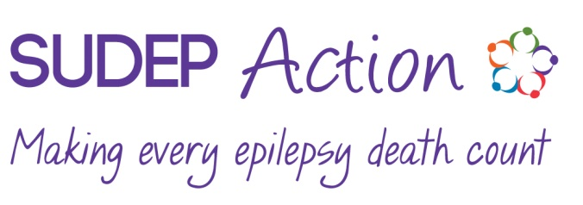
Permissions and information form
We would like to be able to share updates with you about our campaigns, services, fundraising activities and other charity news and events. To do this we would like to determine your preferences using the short form below.
Please note- at any point, you can access our Privacy Policy on our website www.sudep.org
Contact our Data Secretariat for your own copy of our Privacy Policy or to update your permission preferences with us on 01235 772850 or info@sudep.org
Would you like to receive information from SUDEP Action? | Yes |  | No

If yes, please specify how you would like to hear from us.
By email | Yes |  | No
By post | Yes |  | No
By telephone | Yes |  | No
Your information is treated with the utmost confidentiality and we never sell or swap your details.
Your personal information
If you have ticked ‘yes’ to either telephone, post or email, please complete the sections below that will allow us to contact you by those methods.
Title |  | Name
Please indicate that you are over 18 years old

Address
Postcode

Tel |  | Email

How did you hear about SUDEP Action?

If you are bereaved, please provide the following information about the deceased.
Deceased Title |  | Name

Age |  | Relationship to you |  | Date of death

Thank you for your support of SUDEP Action and for adding your voice to all those campaigning for better awareness and understanding of epilepsy mortality including SUDEP.

