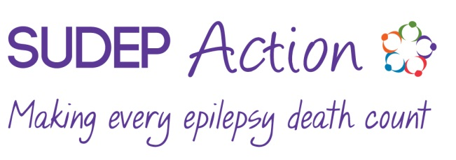
SUDEP Action & SUDEP Action Scotland are the working names of Epilepsy Bereaved -registered charity No. 1050459 (England & Wales), SC045208 (Scotland).
Gift Aid declaration – for past, present & future donations

Please treat as Gift Aid donations all qualifying gifts of money made
□ today □ in the past 4 years □ in the future
Please tick all boxes you wish to apply.
I confirm I have paid or will pay an amount of Income Tax and/or Capital Gains Tax for each tax year (6 April to 5 April) that is at least equal to the amount of tax that all the charities or Community Amateur Sports Clubs (CASCs) that I donate to will reclaim on my gifts for that tax year. I understand that other taxes such as VAT and Council Tax do not qualify. I understand the charity will reclaim 25p of tax on every £1 that I give.

Donor’s details
Title First name or initial(s) . Surname .
Full home address .
.
Postcode .
Date .
Signature .
Email (opitional) .
Donation amount: .

Please notify us if you:
- Want to cancel this declaration
- Change your name or home address
- No longer pay sufficient tax on your income and/or capital gains.

If you pay Income Tax at the higher or additional rate and want to receive the additional tax relief due to you, you must include all your Gift Aid donations on your Self Assessment tax return or ask HM Revenue and Customs to adjust your tax code.
Data protection
We would like to keep you in touch with our work through occasional newsletters and information about events.
Please tick here □ if you would prefer not to receive information from us.
Please return the completed form to SUDEP Action, 12A Mill Street, Wantage, OX12 9AQ

